Enter the created Session ID from previous request

<https://docs.atlassian.com/software/jira/docs/api/REST/7.6.1/#api/2/issue-updateComment>

To create a issue, A PROJECT SHOULD BE CREATED IN JIRA

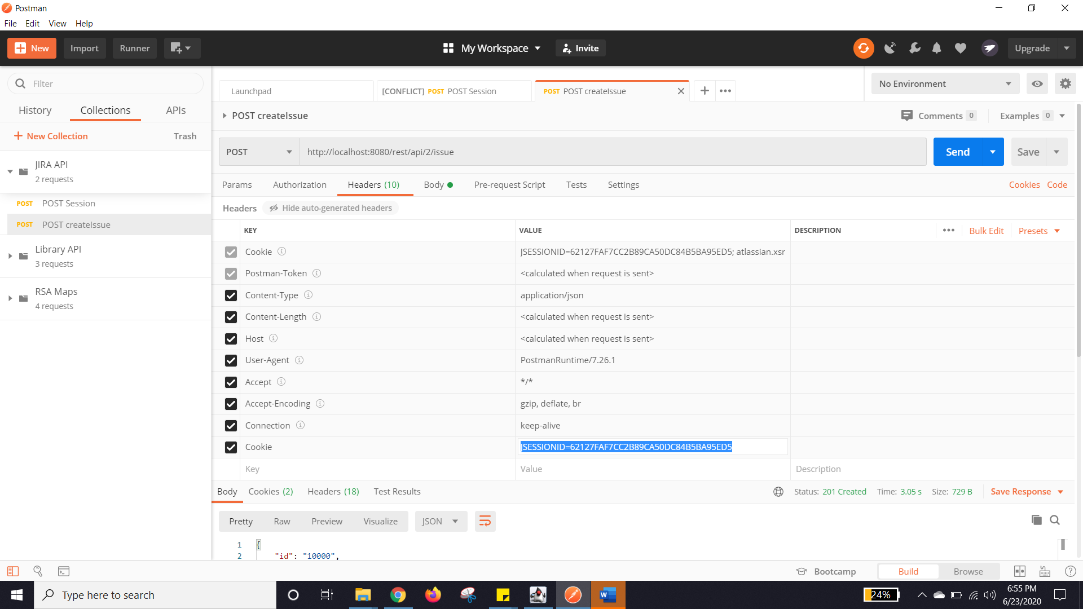

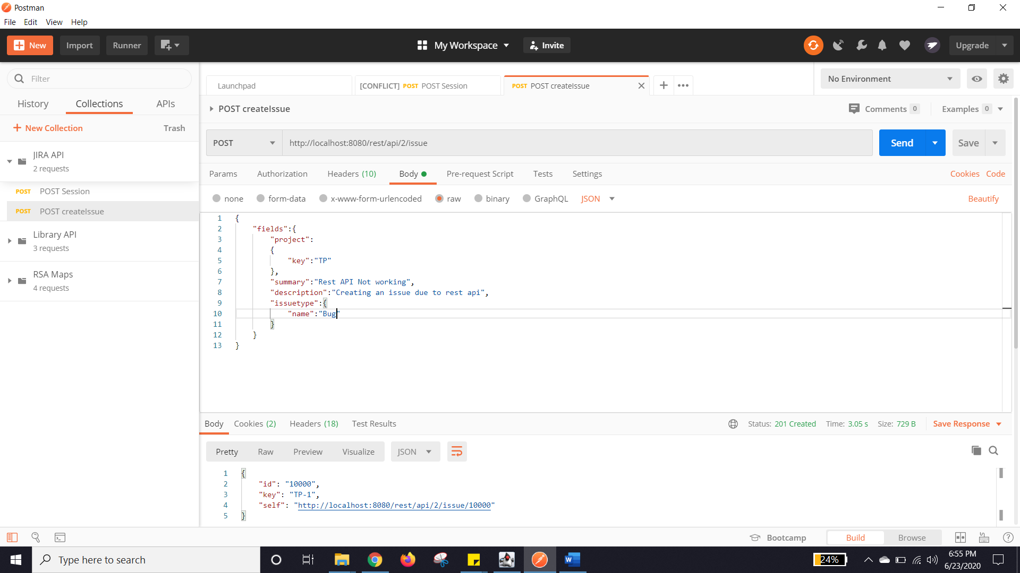

Output created

